TIPS FOR BETTER NATURE PICTURES, by Lisa Culp

I started taking nature pictures about 10 years ago when I
discovered that wildflowers appeared every Spring in the
woods…so not only did I not know anything about nature,
I did not know anything about photography beyond “point
and shoot.”

Since then I have been on a wonderful journey! I have
learned a lot about local nature, and a little about
photography.

The point of my presentation is that you do not need
fancy equipment or a lot of expertise to make fun and
informative nature pictures. So if you are expecting
a lot of technical advice, I’m sorry to inform you that you
came to the wrong presentation But I am happy to share
what I have learned!

The first thing people ask is what camera I use.

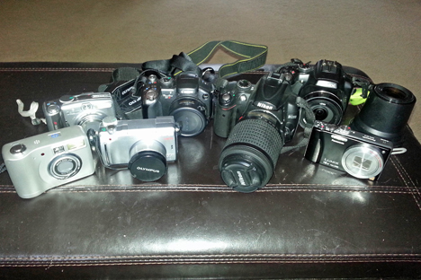

I started with a hand-me-down point and shoot in the early digital years and slowly progressed through a couple super zooms until I bought a Nikon digital SLR (D5000). Of course the challenge in much of nature photography is getting close enough to
get a decent shot, so then I invested in a 200mm and a
300 mm lens. I was getting wonderful shots, but was
frustrated that I was restricted to either close-up shots or
telephoto shots unless I wanted to carry multiple lenses
with me. The past two years I have been using the
Panasonic DMC-FZ200 camera (back right in the photo, with the optional 1.7 tele lens next to it), which allows me to shoot
either close-up or telephoto. It’s also much lighter than
a DSLR, which is important to me because I often bring my
camera with me when I’m doing other volunteer work. Of
course this smaller camera does not get quite the same
quality picture as the larger DSLR, but that's one of the
main things I’ve learned: unless you have unlimited time
and money, you will not get the quality shots that you see
in the magazines! Fortunately for me, that’s not important,
since my goal is to gain a window into nature and make
some beautiful pictures to share with my friends at
the same time. I have taken many, many nice pictures with
a pocket camera, so don’t feel like having a great camera
is important. What IS important is to use your camera and
get to know how to best use it. One of my favorite sayings is
“it’s the Indian, not the arrow.”

The second thing people ask me is, “How did you SEE
that?” The answer brings us to my five main rules of
nature photography:
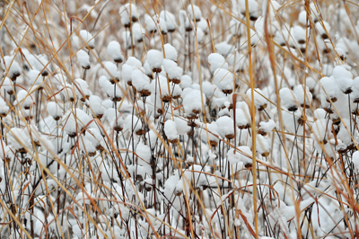
- Get out in the preserves, at all times of year.
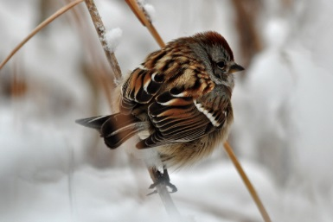

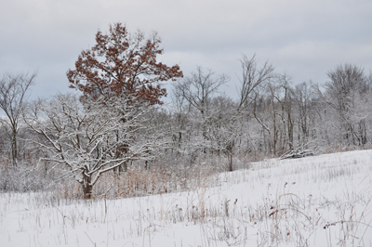

- Walk slowly and quietly, preferably by yourself.

- Look for what doesn’t quite fit, or anything that moves (notice heron on branch).

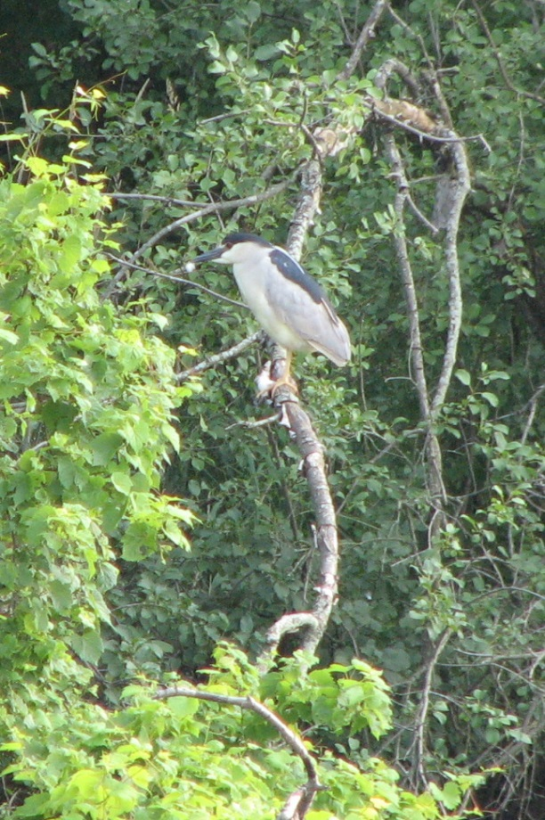
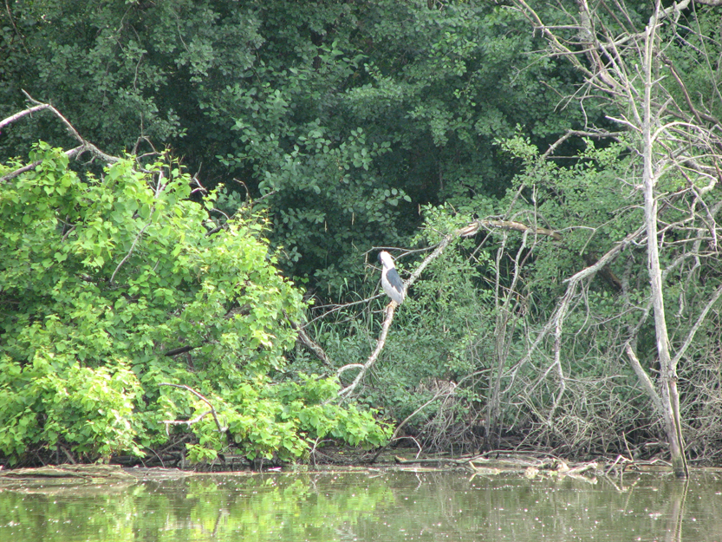

- Shoot early and often, and from as many different sides and angles as possible.
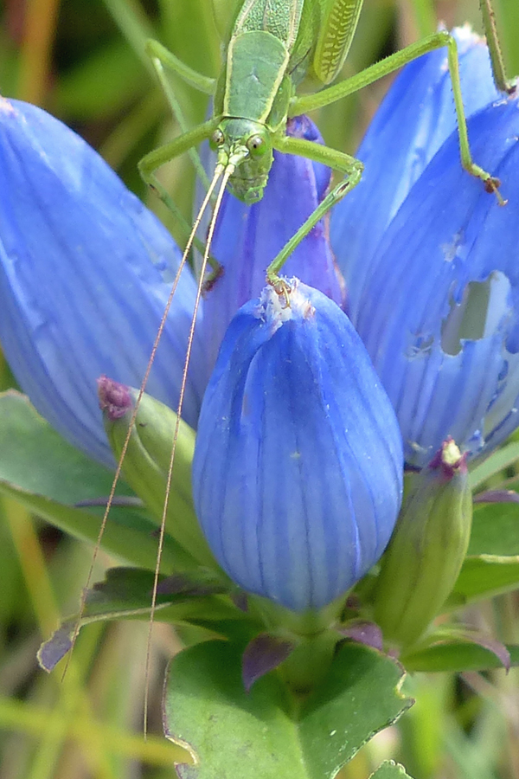

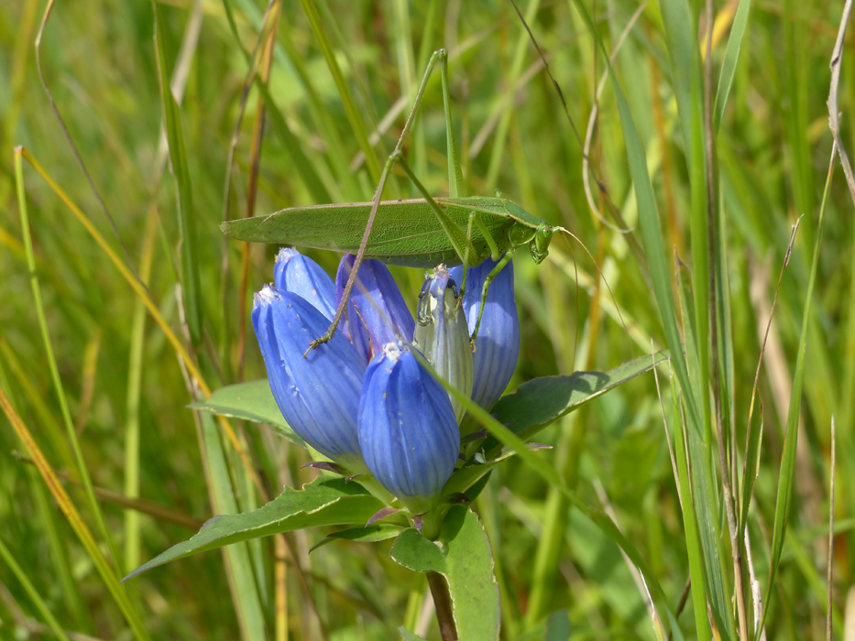

- Try lots of different shots, even if you think it won’t work. Once you see it on the computer at home you may change your mind.

The more time you spend in an environment, the more you
know what “normal” looks like. So when you see something
that stands out a little, it’s potentially interesting!

It’s great to go to the same place all the time. You know
way around, you feel safe, and you learn where things tend
to hang out. Some things I’ve learned include:

--keep your ears tuned to tiny cheeps and peeps to find birds

--hummingbirds love cardinal flower

--always check blooming milkweeds because they attract lots of insects, esp butterflies and hummingbird moths

--great horned owl nests are in the tops of the trees and are large, wide, and made of sticks, whereas squirrel nests are balls of leaves

--bluebirds like to perch about 10 feet above the ground on a horizontal branch, and drop down to feed, then come back up.

--Twelve-spotted skimmer dragonflies will return to the same perch again and again

--ruby meadowhawks are hams

--golden crowed kinglets are often feeding in the leaf litter

--an extra big bug flying slowly is usually a mating pair of somethings, easy to photograph!

--if you find a bird or a bug that’s posing for longer than normal, it often has just caught a meal

--black saddlebags and green darners perch down low in the grasses

--not all beautiful scenes make good pictures. Spend time trying different compositions and angles. Use the macro setting, as it will allow you to focus from a closer distance. At the same time, the background of the picture will be out of focus, which makes your subject stand out nicely.

--when photographing flowers, bright sunshine is not your friend. The ideal lighting is a slightly overcast day…but if it’s sunny out, it’s a good time for macro shots of bugs or other small things.

It’s very educational to explore different preserves. We
are so fortunate that we have such a wide variety of habitats
in the Chicago area. It was another revelation to me:
savannas, prairies, fens, dunes, woodlands, north, south…
each one has a unique ecosystem and thus a different set
of plants, birds and bugs.

Western Chorus Frog story: (I spent hours by the ponds in the spring, trying to see those Chorus frogs that made all that noise, but never saw a one. So finally I took pictures of the vegetation in the pond, using my 300 mm lens. Then I went home and finally found a few frogs by zooming way in and searching each picture! By doing that I figured out what to look for, so now I’ve finally gotten some pictures of Western Chorus Frogs!)

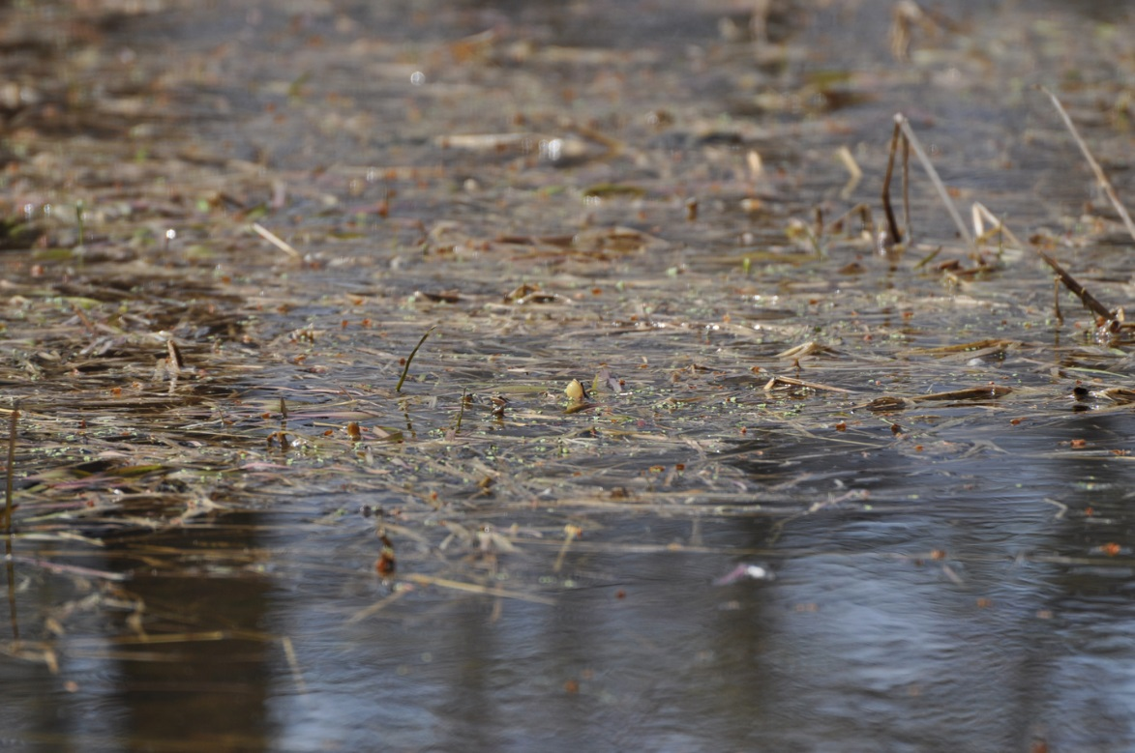

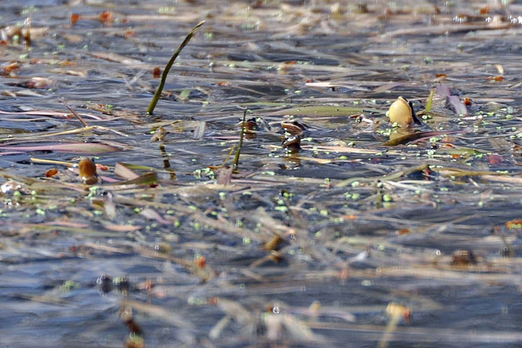

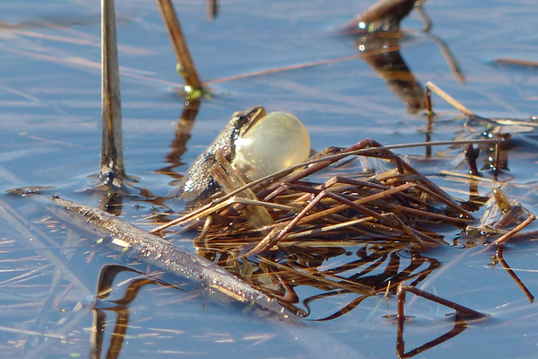

Serendipity: This part of the presentation highlighted pictures I got simply by being lucky: being out there, and paying attention…which is most of the time!! If you go to my Flickr page, you’ll see: www.flickr.com/photos/lc10s/

Lastly, I highlighted some pictures that I took with a pocket camera. Some of them are below: they are often poor quality, but we still get a thrill out of seeing and “snapping” the scene!

